The Times, They are a Changing
Faunal Changes in the Southeast over the last 14,000 years
Teacher’s Manual
Topic: Scientific investigation, ecosystems, adaptation Primary Objective:
Students will examine faunal casts to discover how fauna have changed over the last 14,000 years.
California NGSS Alignment:
Grade 2 | 2-PS1-4 | Construct an argument with evidence that some changes caused by heating or cooling can be reversed and some cannot
Grade 3 | 3-LS3-2 | Use evidence to support the explanation that traits can be influenced by the environment
 | 3-LS4-1 | Analyze and interpret data from fossils to provide evidence of the organisms and the environment in which they lived long ago.
 | 3-LS4-3 | Construct an argument with evidence that in a particular habitat some organisms can survive well, some less well, and others not at all.
 | 3-LS4-4 | Make a claim about the merit of a solution to a problem caused when the environment changes and the types of plants and animals that live there my change.
Grade 4 | 4-ESS1-1 | Identify evidence from patterns in rock formations and fossils in rock layers to support an explanation for changes in landscape over time.
Grade 5 | 5-ESS2-1 | Develop a model using an example to describe ways the geosphere, biosphere, hydrosphere, and/or atmosphere interact.
Grade 7 | MS-LS2-1 | Analyze and interpret data to provide evidence for the effects of resource availability on organisms and populations of organisms in ecosystems.
 | MS-LS2-4 | Construct an argument supported by empirical evidence that changes to physical or biological components of an ecosystem affect populations.
Grade 8 | MS-LS4-1 | Analyze and interpret data for patterns in the fossil record that document the existence, diversity, extinction, and change of life forms throughout the history of life on Earth under the assumption that natural laws operate today as in the past.
 | MS-LS4-2 | Apply scientific ideas to construct an explanation for the anatomical similarities and differences among modern organisms and between modern and fossil organisms to infer evolutionary relationships.
High School | HS-LS2-6 | Evaluate the claims, evidence, and reasoning that the complex interactions in ecosystems maintain relatively consistent numbers and types of organisms in stable conditions, but changing conditions may result in a new ecosystem.
 | HS-LS4-5 | Evaluate the evidence supporting claims that changes in environmental conditions may result in: 1) increases in number of individuals of some species, 2) the emergence of new species over time, and 3) the extinction of other species.

Background Knowledge:
This activity uses casts of fossils to examine changes in southeastern North America’s fauna over the last 14,000 years.
The casts are all either individual teeth or tooth rows from mammals. For paleontologists, fossil teeth are the most common fossil remains that are easily identified; complete skeletons of fossil animals are extremely rare. The 83 specimens in the kit come from five states (Virginia, North Carolina, South Carolina, Georgia, and Florida), 10 taxa, and three different periods. The casts are color-coded to represent the different times:
Gray or black — 14,000 years before present (YBP):
Light brown — 1,000 YBP:
Off-white — modern day:
Two major events control the patterns seen in these fossils:
- The end of the last glacial period at the end of the Ice Age approximately 10,000 years ago.
The end of the Ice Age saw the extinction of a large number of animals, including mastodons, the woodland musk ox, and all the New World species of horses. Your students may be familiar with other Ice Age species that went extinct at this time, including mammoths and sabertooth cats. While the ice sheet only reached south to New York, cold conditions (similar to modern Alaska) extended at least as far south as Virginia. This can be seen by the presence of cold weather species such as the woodland musk ox and caribou. Other cold-weather animals, such as woolly mammoths are also known from Virginia at this time.
As the climate generally warmed after the end of the Ice Age other animals were able to move north, including opossum, fox squirrels, and armadillos. Note: this modest increase in temperatures since the end of the Ice Age should not be confused with the much more rapid increase in temperature that has occurred over the last 150 years, that are due primarily to human activities.
The patterns for some of these animals will be somewhat different depending on your location. For example, 14,000 years ago opossums were already in Florida, which never got as cold as Virginia. Moreover, elk apparently never got as far south as Florida. But otherwise, these trends will hold for any eastern state between New York and Georgia.
2. Arrival of large numbers of Europeans in North America approximately 400 years ago.
There were several significant faunal changes associated with the arrival of Europeans in North America. Due to hunting and habitat loss, some species that survived the end of the Ice Age were wiped out in eastern North America, including elk, bison, and passenger pigeons.
In addition, several domestic European species were introduced, including pigs and horses Note that native North America horses went extinct at the end of the Ice Age. Modern horses in North America are all descended from closely related European horses.
Optional Discussion Points: The Pleistocene Epoch is typically accepted as ending approximately 10,000 years ago, at the end of the last Ice Age. In trying to determine if a fossil deposit is Pleistocene, it is common to use the presence of “Pleistocene megafauna” (such as Mammut) as a determining marker. There is some debate about the arrival time of opossum in Virginia. There are no published records of opossum being found with any uniquely Pleistocene animals such as mammoth or mastodon. Moreover, several Pleistocene cave deposits in western Virginia have been thoroughly examined, and there were no opossums identified from among the several thousand bones present. However, there are some reports of opossum from Virginia that are of unknown age.
Almost all records of Pleistocene mammals from Virginia come from sites in the Appalachian Mountains. It might be expected that these areas were the coldest parts of Virginia during the Pleistocene (as they are today), so that the fauna of these areas may not be representative of the entire state. It’s possible that the Piedmont and Coastal Plain regions had a warmer-climate fauna than the mountains.
A comparison of Virginia to other southeastern states is informative. For example, caribou and elk are known from the Carolinas and northern Georgia, but not Florida. The giant ground sloth Eremotherium has not been reported north of North Carolina, and its distribution may be similar to the opossum. This suggests that the region from North Carolina to Georgia was a transitional zone with a mix of warm-weather species (opossum, Eremotherium) and cold-weather species (elk, caribou).
Some species were especially widespread during the Pleistocene and are found in many parts of North America, from northern Canada or Alaska to Florida. These include living species such as black bear (Ursus americanus), white-tailed deer (Odocoileus virginianus), and groundhog (Marmota monax) as well as extinct species such as mastodon (Mammut americanum), certain ground sloths (Megalonyx jeffersonii), and giant beaver (Castoroides ohioensis).

Materials:
• 83 casts replicas of mammal teeth • 10 identification cards
Vocabulary: fauna, Ice Age, Pleistocene Epoch (geologic timescale)
Name: ____________________________ Date: _______________
The times, they are a changing
(Teacher’s version)
Purpose: To examine faunal changes over the last 14,000 years.
Fossils are the remains of ancient organisms that have been preserved in rocks or sediments. Usually, only the hard parts of an organism’s body, such as bones, teeth, and shells, are preserved. While fossils can tell us what past organisms looked like and how they are related to other organisms, there are many other things that paleontologists can learn from studying fossils. For example, it is possible to look at the whole community (or assemblage) of organisms in a particular place (fauna, for animals). If the fauna changes over time, it can provide clues about how the environment has changed. Much of our knowledge of the Earth’s past geography and climate comes from the study of fossil assemblages.
For this exercise you will be examining specimens of mammals that are known to have lived in the southeast during the last 14,000 years. In working with fossils, one of the challenges is that we are limited in the amount and type of data available to us. For example, when working with vertebrates such as mammals it is extremely rare to find an entire skeleton, or even a large part of one. The most common remains are individual teeth, so a paleontologist working on mammals needs to learn to identify animals from as little as a single tooth.
In this exercise you will be identifying casts of individual teeth (or, in some cases, rows of teeth). Since real fossils are both fragile and rare, you will be working with cast replicas of fossils. You have been provided with ID cards to help you identify your casts; the ID cards in most cases include photos of the original fossils.
Samples included in Climate Change Kit
- American mastodon (Mammut): This is an extinct relative to modern elephants. Mastodon fossils have been found from coast-to-coast, from as far north as Alaska and to far south as Mexico.
- Horse (Equus): Wild horses live in grasslands in a variety of climates.
- Elk (Cervus): Elk are large deer that today live mostly in mountainous parts of western United States and Canada.
- White-tailed deer (Odocoileus): This is the same species of deer that is
commonly seen in rural parts of Virginia today. Modern white-tailed deer are found from Canada to Central and South America, and in almost every state.
- Caribou or reindeer (Rangifer): Caribou are a type of deer that today are
found in Canada, Alaska, Greenland, and northern Europe.
- Opossum (Didelphis): Opossums are the only marsupials found in North
America.
They originally evolved in South America before moving north, and prefer warmer climates.
- Pig (Sus): Wild versions of the domestic pig were found across central Europe and Asia.
- Sloths (Eremotherium and Megalonyx): Extinct, giant ground sloths. Relatives of modern anteaters, armadillos, and tree sloths.
- Bear (Ursus): This is the same species of bear found in the southeast today.
Procedure:

Option 1 Age sorting

Sort the teeth according to color. Each color represents a different age for when the animal was alive. Give the fossils to each of three groups.
- Using the labels on the bottom of the teeth, sort the teeth into the states in which they were found.
- Using the identification cards, determine the species for each tooth. The same species may occur in more than one time period.
- Fill out the chart below, indicating which genera were found in each state for the given time period.
- Have groups pool their results.
Option 2 State Sorting
Sort the teeth according to the state labels on the bottom of each tooth. Give the fossils to each of five groups.
- Sort the teeth by color.
- Identify each of the teeth using the identification cards.
- Fill out the chart below; indicate which genera were found in each time period for the given state.
- Have groups pool their results.

Option 3 Taxa Sorting
Sort the teeth according to the shape of each tooth. Give the fossils to each of ten groups.
- Identify each of the teeth using the identification cards.
- Fill out the chart below; indicate which genera were found in each time period and each state.
- Have groups pool their results.
Key for all times and all taxa for teachers
Virginia
Gray or black — 14,000 years before present (YBP):  American mastodon (Mammut americanum) upper premolar  Horse (Equus sp.) upper molar  Elk (Cervus canadensis) upper molar  White-tailed deer (Odocoileus virginianus) upper molar  Caribou (Rangifer tarandus) lower premolar | Light brown — 1,000 YBP:  Elk (Cervus canadensis) upper molar  White-tailed deer (Odocoileus virginianus) upper molar  Opossum (Didelphis virginiana) palate | Off-white — modern day:  White-tailed deer (Odocoileus virginianus) upper molar  Opossum (Didelphis virginiana) palate  Horse (Equus sp.) upper molar  Pig (Sus scrofa) upper molar
North Carolina  Dark brown — 14,000 years before present (YBP): | Light brown — 1,000 YBP: | Off-white — modern day:
American mastodon (Mammut americanum) upper premolar  Elk (Cervus canadensis) upper molar  Horse (Equus sp.) upper molar  White-tailed deer (Odocoileus virginianus) upper molar  Caribou (Rangifer tarandus) lower premolar  Sloth (Megalonyx jeffersoni)  Sloth (Eremotherium sp) | Elk (Cervus canadensis) upper molar  White-tailed deer (Odocoileus virginianus) upper molar  Opossum (Didelphis virginiana) palate  Bear Ursus sp. | White-tailed deer (Odocoileus virginianus) upper molar  Opossum (Didelphis virginiana) palate  Horse (Equus sp.) upper molar  Pig (Sus scrofa) upper molar  Bear (Ursus sp)

South Carolina  Dark brown — 14,000 years before present (YBP): | Light brown — 1,000 YBP: | Off-white — modern day:
American mastodon (Mammut americanum) upper premolar  Horse (Equus sp.) upper molar  White-tailed deer (Odocoileus virginianus) upper molar  Caribou (Rangifer tarandus) lower premolar  Elk (Cervus canadensis) upper molar  Sloth (Megalonyx jeffersoni)  Sloth (Eremotherium sp) | White-tailed deer (Odocoileus virginianus) upper molar  Opossum (Didelphis virginiana) palate  Bear Ursus sp. | White-tailed deer (Odocoileus virginianus) upper molar  Opossum (Didelphis virginiana) palate  Horse (Equus sp.) upper molar  Pig (Sus scrofa) upper molar  Bear (Ursus sp)
Georgia  Dark brown — 14,000 years before present (YBP): | Light brown — 1,000 YBP: | Off-white — modern day:
American mastodon (Mammut americanum) upper premolar  Horse (Equus sp.) upper molar  White-tailed deer (Odocoileus virginianus) upper molar  Caribou (Rangifer tarandus) lower premolar  Elk (Cervus canadensis) upper molar  Bear (Ursus sp)  Elk (Cervus canadensis) upper molar  Sloth (Megalonyx jeffersoni)  Sloth (Eremotherium sp)  Opossum (Didelphis virginiana) | White-tailed deer (Odocoileus virginianus) upper molar  Opossum (Didelphis virginiana) palate  Bear (Ursus sp.) | White-tailed deer (Odocoileus virginianus) upper molar  Opossum (Didelphis virginiana) palate  Horse (Equus sp.) upper molar  Pig (Sus scrofa) upper molar  Bear (Ursus sp)

Florida  Dark brown — 14,000 years before present (YBP): | Light brown — 1,000 YBP: | Off-white — modern day:
American mastodon (Mammut americanum) upper premolar  Horse (Equus sp.) upper molar  White-tailed deer (Odocoileus virginianus) upper molar  Caribou (Rangifer tarandus) lower premolar  Elk (Cervus canadensis) upper molar  Bear (Ursus sp)  Elk (Cervus canadensis) upper molar  Sloth (Megalonyx jeffersoni)  Sloth (Eremotherium sp)  Opossum (Didelphis virginiana) | White-tailed deer (Odocoileus virginianus) upper molar  Opossum (Didelphis virginiana) palate  Bear (Ursus sp.) | White-tailed deer (Odocoileus virginianus) upper molar  Opossum (Didelphis virginiana) palate  Horse (Equus sp.) upper molar  Pig (Sus scrofa) upper molar  Bear (Ursus sp)

Teacher’s Notes:
There are a few ways in which students can be grouped. Three options are presented. For Option 1, each of five student groups get the fossils from one state. The groups will color sort the fossils, identify them, complete the chart for their state, then pool their data. For the modern era students will need to rely on their knowledge or Google the taxon to see which live in each state.
Option 2 is similar, but students get the fossils from one taxon. Each of the ten student groups will again color sort the teeth and identify which they have. They will use the provided KMZ file to open in Google Earth to identify where fossil teeth have been found. Again, personal knowledge or a Google search will be necessary to identify the extent of modern fauna.
For Option 3, each of three groups get the fossils from a particular time period. They must identify which teeth they have and use the KMZ file to determine where each fauna lived.
You can subdivide the students any way you would like depending on how many groups you want to have. You can subdivide into groups by state and time period (15 groups) by taxon and age (30 groups) or any other way you choose.

Reflection Questions (to be completed after the data collection phase of the activity):
1) Which species were present 14,000 years ago that were absent by 1,000
years ago?
Mastodon, musk ox, caribou and horse. Students may not include horse, since it appears again in the modern sample.
2) Which species show up for the first time 1,000 years ago?
Opossum
3) Which species were present 1,000 years ago, but are no longer present in the southeast?
Elk
4) Which species only occur in modern times?
Pig
5) Do any of the animals from 14,000 years ago suggest that the climate in the southeast was different than that it is today? Explain.
Musk oxen and caribou prefer colder climates than what is found in modern Virginia. Their presence suggests that the climate in Virginia was colder 14,000 years ago than it is today. Note that students may not be familiar with caribou and musk oxen, and may need to be told about their habits or allowed to do research to find out. It may help to point out that caribou is the North American name for reindeer; they are the same species. In addition, it seems that opossums only moved into Virginia after the end of the Ice Age, after the climate began to warm.
6) What major event occurred in the southeast within the last 1,000 years that could explain the changes in fauna between 1,000 years ago and modern day? Explain.
The arrival of Europeans around 400 years ago caused big changes in the Virginia fauna. Some species, such as elk, were wiped out by hunting, and domestic species from Europe, such as pigs, were introduced to North America.
7) Horses show a pattern that is different from all the other animals in this exercise. How can you explain this difference?
Horses were present in North America 14,000 years ago and are present here today, but were absent 1,000 years ago. Horses originally evolved in North America, but went extinct here at the end of the Ice Age. Then Europeans reintroduced them 400 years
ago.
Students will probably be familiar with the introduction of horses by Europeans from their history classes, but will probably not know that horses originally evolved in North America. They may suggest that horses were forced out of Virginia by the change in climate (like caribou, etc.) but survived in other parts of North America. In discussion, you can point out to students that apparently there were no horses in North America at all between 10,000 years ago and 400 years ago.
8) Which of these species seem to be especially able to cope with changing conditions? Why might this be?
White-tailed deer are found in all three samples, so they survived both the warming climate at the end of the Ice Age and the arrival of Europeans.

Name: ________________________ Date: _______________
The times, they are a changing: Student version
Purpose: To examine faunal changes over the last 14,000 years.
Fossils are the remains of ancient organisms that have been preserved in rocks or sediments. Usually, only the hard parts of an organism’s body, such as bones, teeth, and shells, are preserved. While fossils can tell us what past organisms looked like and how they are related to other organisms, there are many other things that paleontologists can learn from studying fossils. For example, it is possible to look at the whole community (or assemblage) of organisms in a particular place (fauna, for animals, and flora, for plants). If the flora or fauna changes over time, it can provide clues about how the environment has changed. Much of our knowledge of the Earth’s past geography and climate comes from the study of fossil assemblages.
For this exercise you will be examining specimens of mammals that are known to have lived in the Southeast during the last 14,000 years. In working with fossils, one of the challenges is that we are limited in the amount and type of data available to us. For example, when working with vertebrates such as mammals it is extremely rare to find an entire skeleton, or even a large part of one. The most common remains are individual teeth, so a paleontologist working on mammals needs to learn to identify them from as little as a single tooth.
In this exercise you will be identifying casts of individual teeth (or, in some cases, rows of teeth). Since real fossils are both fragile and rare, you will be working with cast replicas of fossils. You have ID cards to help you identify your casts; the ID cards in most cases include photos of the original fossils.

Procedure:
Option 1 (each student group has the fossils from one state)
- Sort the teeth according to color. Each color represents a different age for when the animal was alive:
- Using the identification cards, determine the species for each tooth. The same species may occur in more than one time period.
- Fill out the chart below, indicating which species were found in each time period.
- When each group is finished you should pool all of your data.
State: __________________
Gray or black — 14,000 YBP: | Light brown — 1,000 YBP: | Off-white – Modern day:

Procedure:
Option 2 (each student group has the fossils from one time period)
- You should have teeth of one color.
- Using the identification cards, determine the species for each tooth. The same species may occur in more than one state.
- Use the appropriate column in the table below to indicate which species were found in each state for your given time period.
- When each group is finished you should pool all of your data.
Time Period: __________________
State | Fossils found during the time period above
VA
NC
SC
GA
FL

Procedure:
Option 3 (each student group has the fossils from one taxon)
- You should have teeth of one or more colors.
- Using the identification cards, determine the species for the tooth. Use the appropriate column in the table below to indicate which species were found in each state and each time period for your taxon.
- When each group is finished you should pool all of your data.
Taxon: __________________
State | Fossils found from the taxon above
 | Gray or black — 14,000 YBP: | Light/dark brown — 1,000 YBP: | Off-white – Modern day:
VA
NC
SC
GA
FL

Reflection Questions:
1) Which species were present 14,000 years ago that were absent by 1,000 years ago?
______________________________________________________________________________________________________________________________________________________________________________________________________
2) Which species show up for the first time 1,000 years ago?
_____________________________________________________________________________________________________________________________________________________________________________________________________
3) Which species were present 1,000 years ago, but are no longer present?
______________________________________________________________________________________________________________________________________________________________________________________________________
4) Which species only occur in modern times?
______________________________________________________________________________________________________________________________________________________________________________________________________
5) Do any of the animals from 14,000 years ago suggest that the climate in the southeast was different than that it is today? Explain. _____________________________________________________________
6) What major event occurred within the last 1,000 years that could explain the changes in fauna between 1,000 years ago and modern day? Explain. __________________________________________________________________________________________________________________________ ____________________________________________________________
7) Horses show an pattern that is different from all the other animals in this exercise. How can you explain this difference? __________________________________________________________________________________________________________________________ _____________________________________________________________
8) Which of these species seem to be especially able to cope with changing conditions? Why might this be? ______________________________________________________________________________________________________________________________________________________________________________________________________

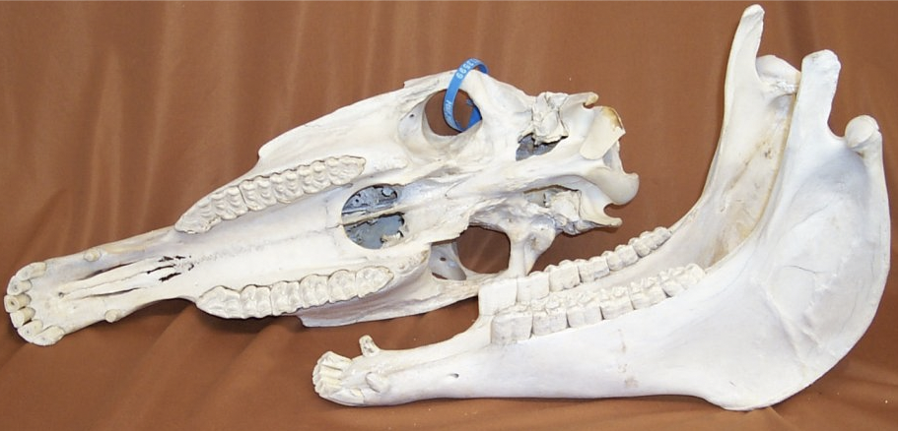
Equus Horse, skull and jaw

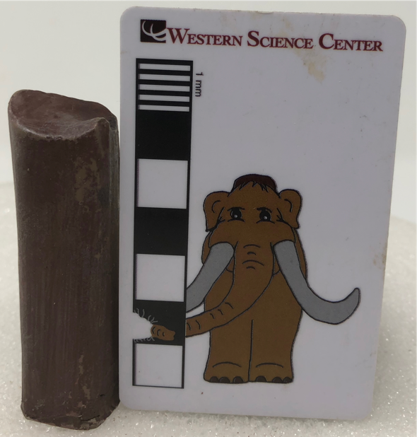
Megalonyx Giant ground sloth, tooth
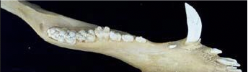
Sus Pig - jaw, left side

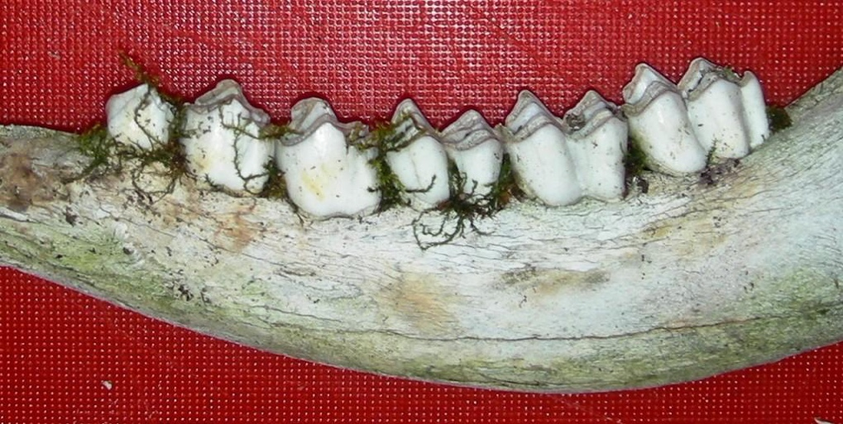
Rangifer Caribou - jaw, left side

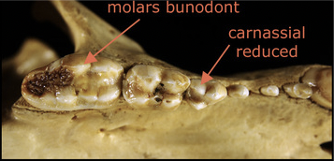
Ursus black bear - palate view, right side
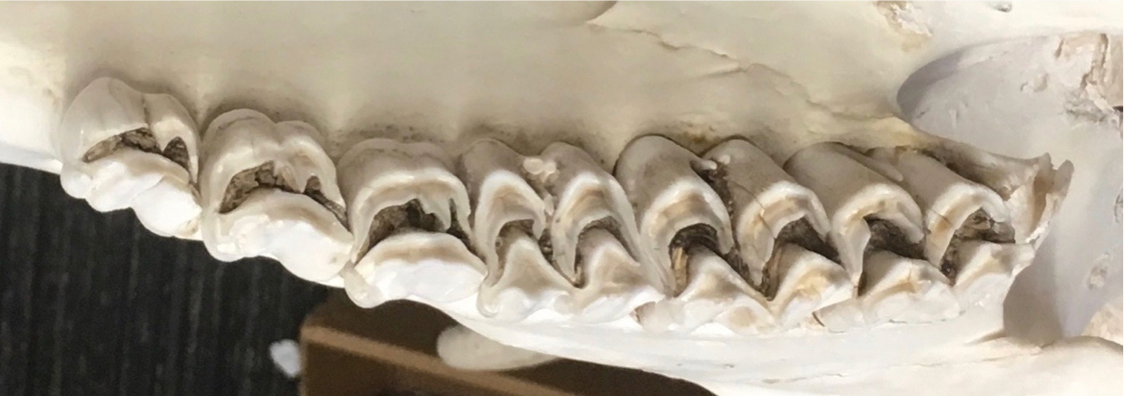
Cervus Elk - palate view, left side

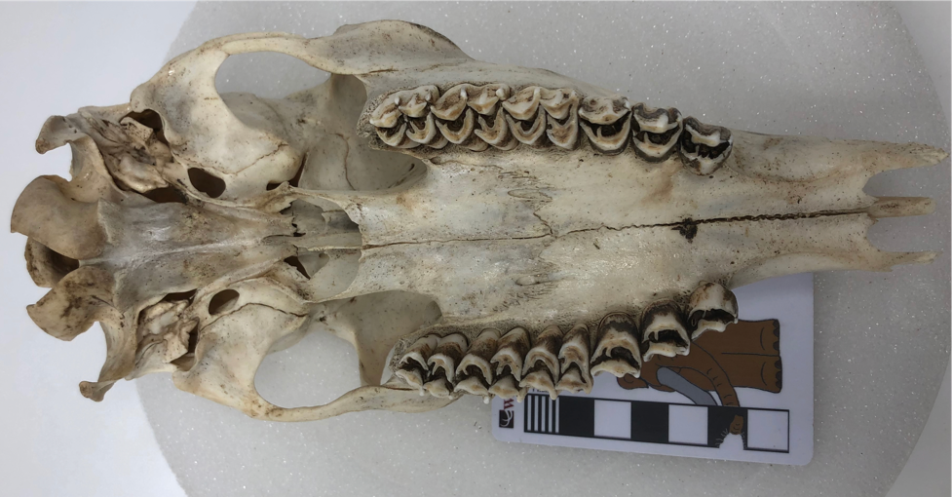
Odocoileus White-tailed deer - palate view

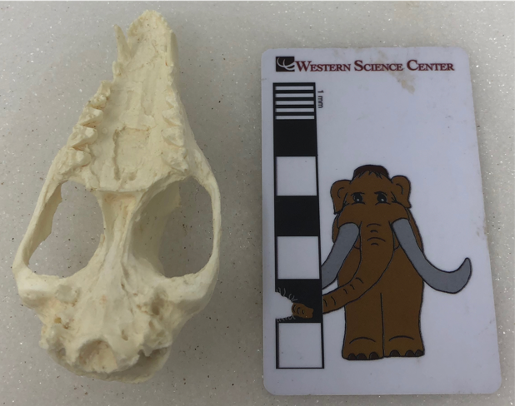
Didelphis Opossum Skull - palate view
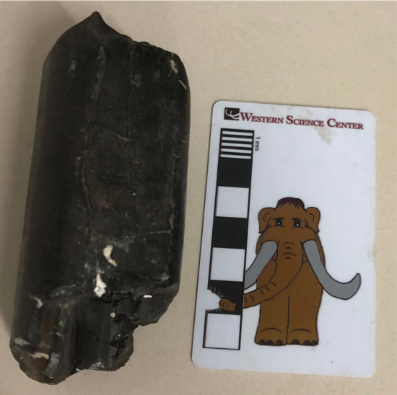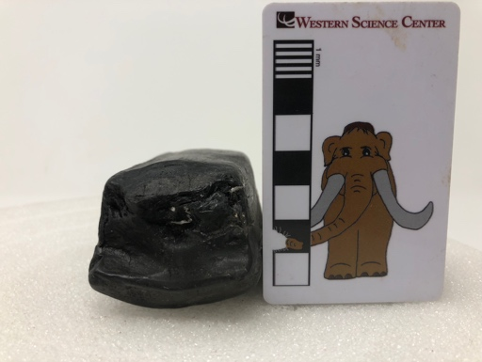
Eremotherium giant ground sloth tooth

Mammut pacificus Pacific mastodon

